A
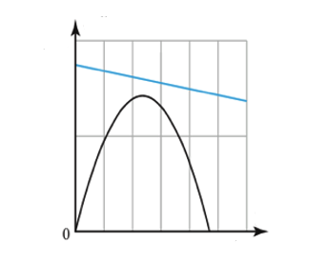

Find the station that models an exponential automobile depreciation function and an increasing linear automobile expense function.

B
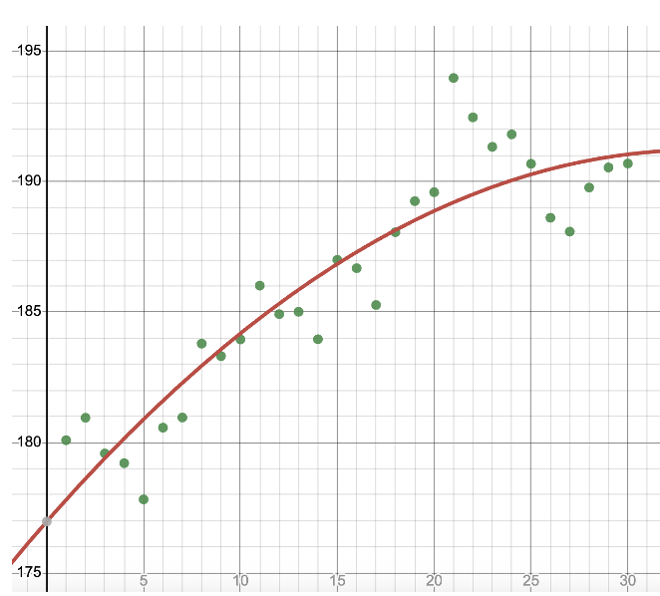

Find the station that models a system of a linear automobile depreciation function and a linear accumulating loan expense function with a down payment.

C
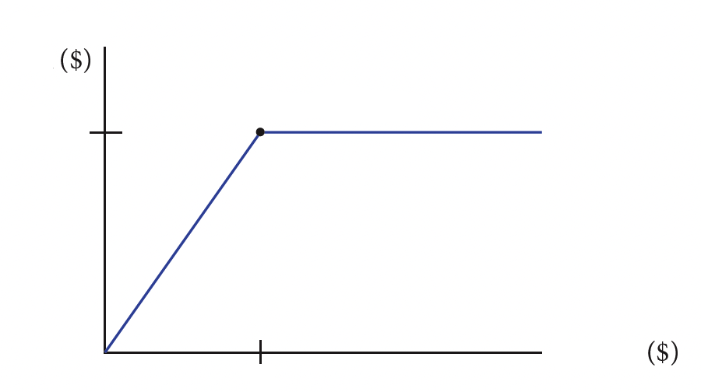

Find the station that models a classified ad pricing plan that charges $41.55 for the first 6 lines of print and $5.50 per line for all lines over 6.

D

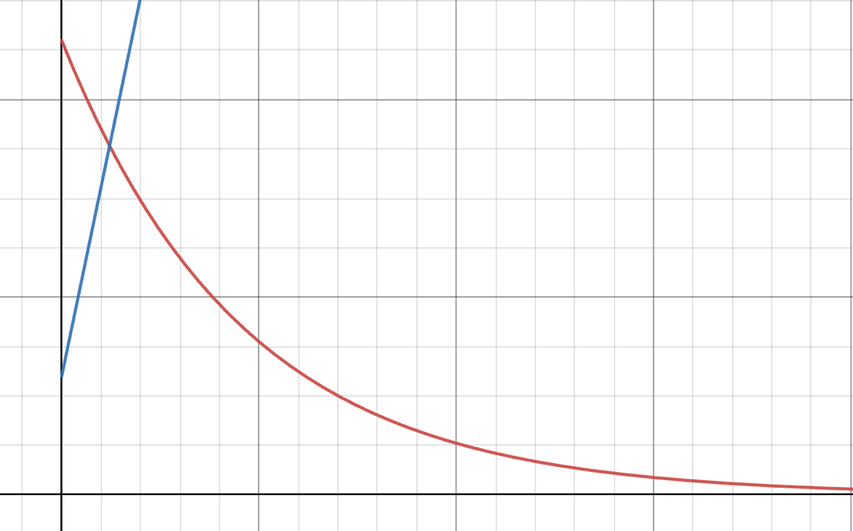

Find the station that models the relationship of the monthly income of select high school seniors and monthly clothing expenses for those seniors.

E

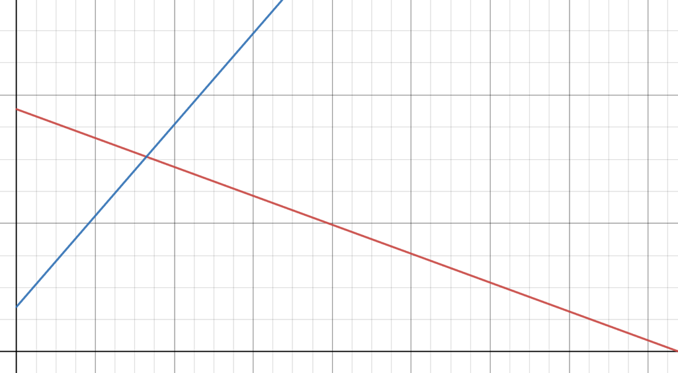

Find the station that models the 15-year loan balances on a $100,000 loan with an interest rate of 7.5% using a regression line.

F

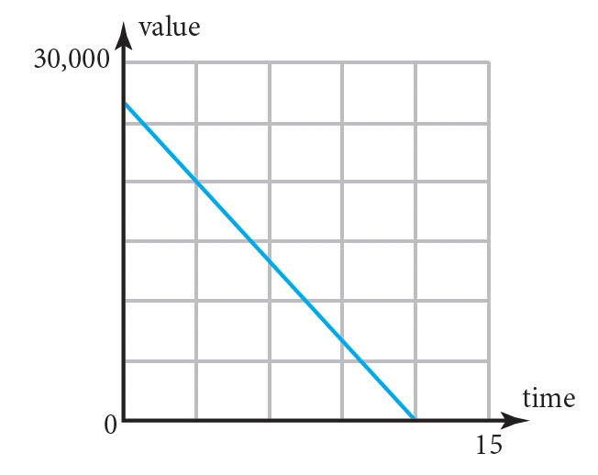

Find the station that models a quadratic revenue equation and a linear expense equation indicating that no profit is to be made from the sale of the product in question.

G

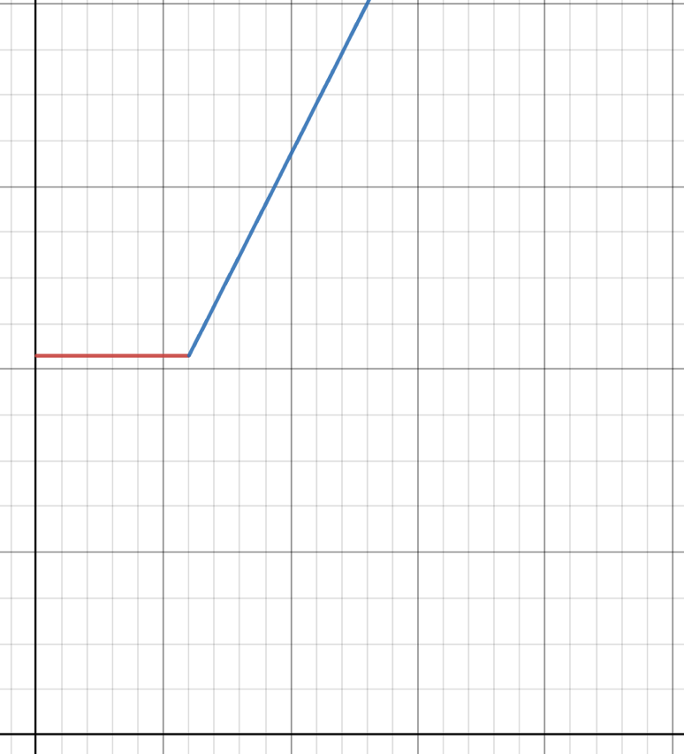

Find the station that models the IRS required straight line depreciation method of a $27,000 car that loses all of its after 12 years.

H

Find the station that models this year’s Social Security tax of 6.2% for incomes up to $160,200, and the fact that once a taxpayer reaches the maximum amount, Social Security tax is no longer paid for the remainder of that year.

I

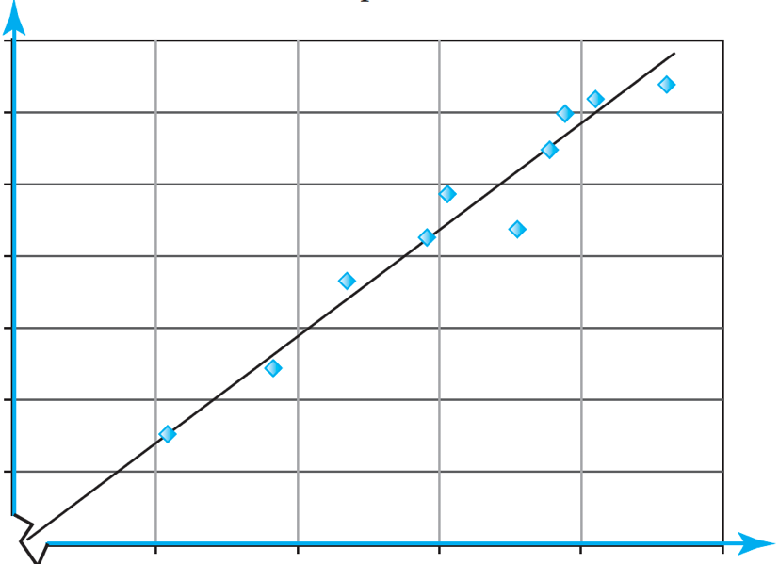

Find the station that models consecutive trading days of closing prices of Apple stock in which the trend appears to show an increase in the price for the first two-thirds of the days with some erratic prices in the last third.

